**Signed APK**

Android requires that all APKs be digitally signed with a certificate before they can be installed.

A public-key certificate, also known as a digital certificate or an identity certificate, contains the public key of a public/private key pair, as well as some other metadata identifying the owner of the key (for example, name and location). The owner of the certificate holds the corresponding private key.

When we sign an APK, the signing tool attaches the public-key certificate to the APK. The public-key certificate serves as a "fingerprint" that uniquely associates the APK to us and our corresponding private key. This helps Android ensure that any future updates to our APK are authentic and come from the original author.

A keystore is a binary file that contains one or more private keys. When we sign an APK for release using Android Studio, we can choose to generate a new keystore and private key or use a keystore and private key we already have. we should choose a strong password for your keystore, and a separate strong password for each private key stored in the keystore. We must keep your keystore in a safe and secure place.

**Steps to create a Signed APK**

1.Goto Build->Generate signed APK

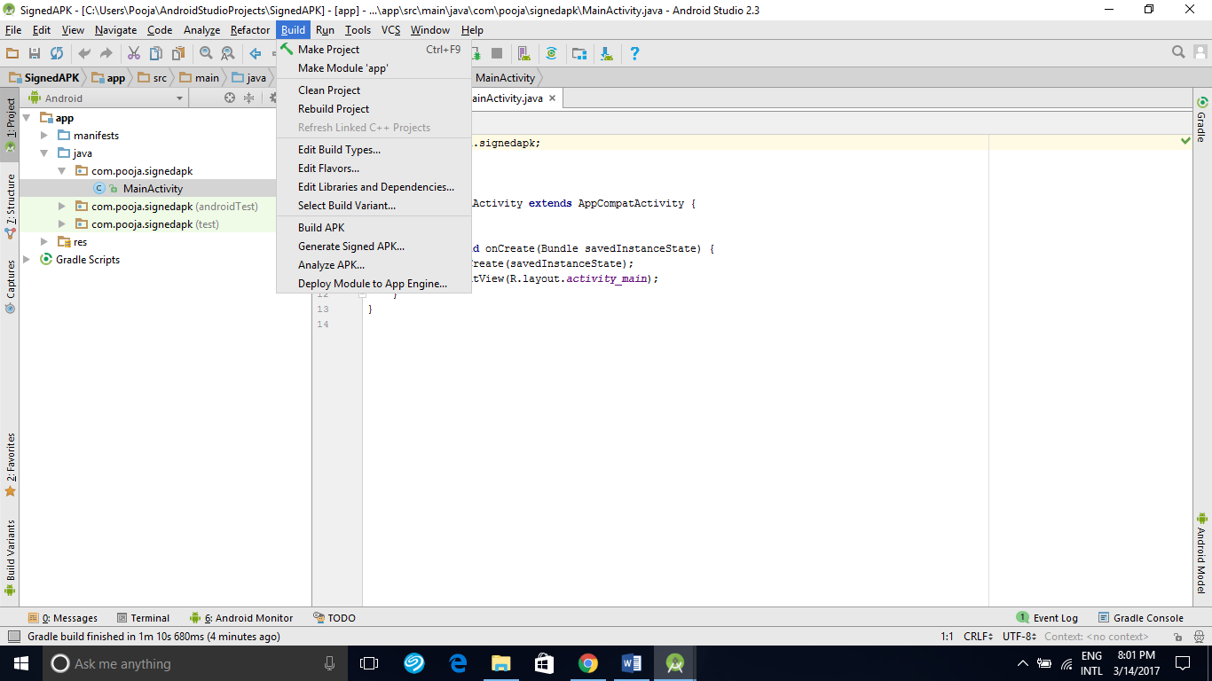

2.Click on create new

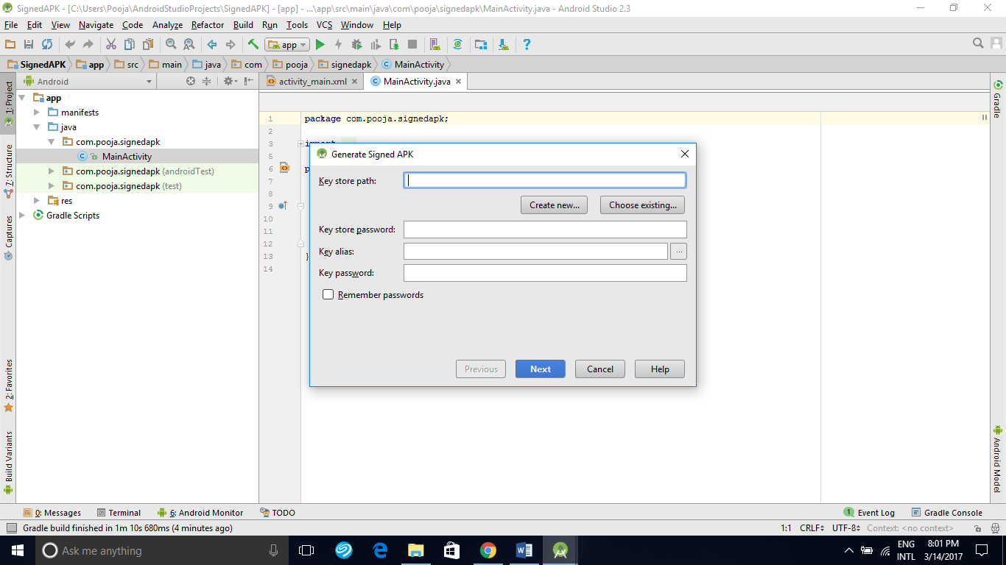

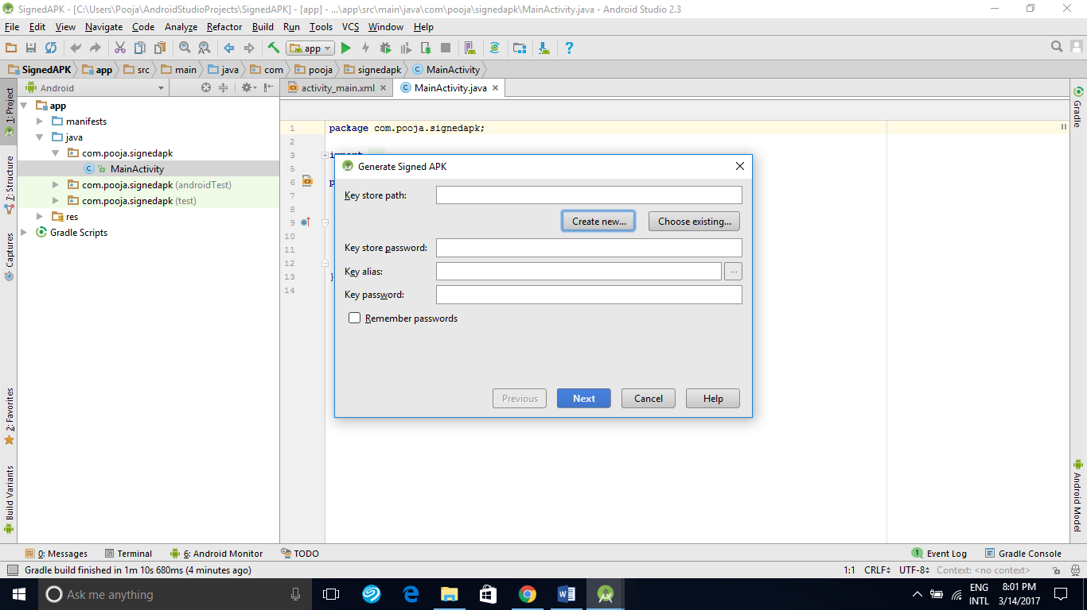

3.Here we have to select a key store path and set password…We have to fill in other details and click on ok.

The validity of the key is for 25 years maximum.

Alias is identifying name for our key.

In the Certificate section we  must enter some information about our self for our certificate. This information is not displayed in our app, but is included in our certificate as part of the APK.

5.On the **Generate Signed APK Wizard** window, select a keystore, a private key, and enter the passwords for both.

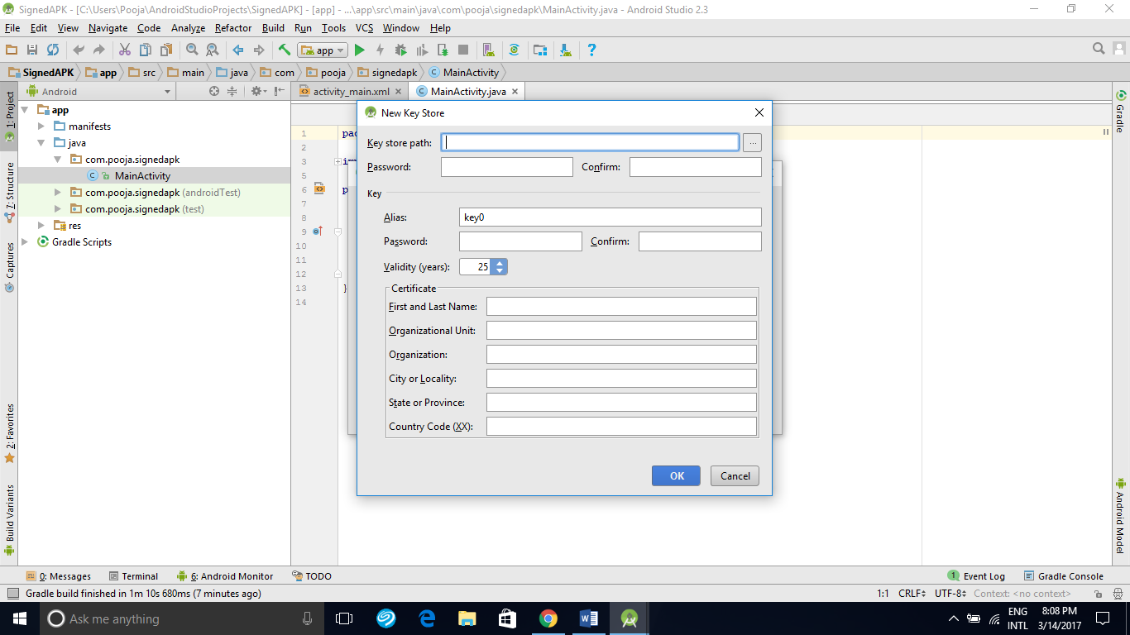

6.On clicking ok key store path will be create

7.we can to set remember password and click next.

8.APK destination folder path will be displayed along with two options debug and release in the next window. If we select release we can publish our app to play store.

9.We can click finish and the android studio will create APK file.

10.A pop up will appear in the right showing “Generated signed APK” show in explorer.

In this folder we will have standard app-release. apk file

11.Now we have generated signed apk and can publish our apps to play store.